**Devops Resume for 2 years**

**=================================================================**

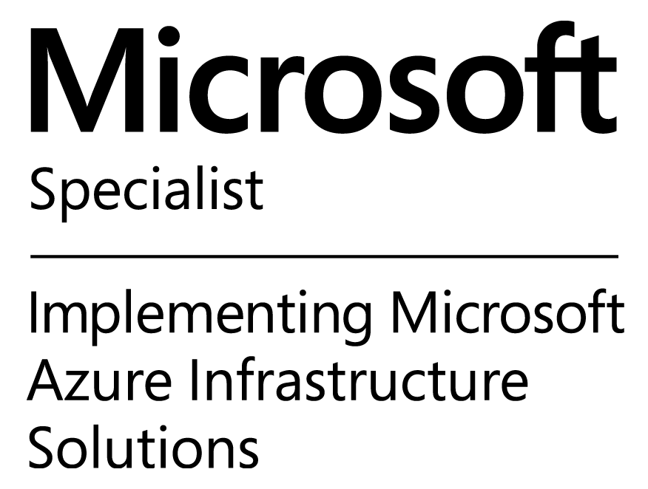

**Your Name**

**E-Mail:** Your email Id (your certificate log0)

**Mobile:** +91-XXXXXXXXXXX

**Seeking middle level assignments in DevOps/ AWS/ Cloud Engineer with an organization of high repute preferably in IT Sector**

**PROFILE SUMMARY:**

* Experienced in DevOps tools such as Chef, Vagrant, Virtualbox, Ansible, Jenkins, Maven, SVN, GIT, and Docker.
* Experienced in strategy and practical implementation of AWS Cloud-Specific technologies which include EC2, EBS, S3, VPC, RDS, ELB, ECS, Cloudformation, Cloudwatch, Lambda and RDS MySQL.
* Worked on cross platform tools such as version control.
* Experienced in setting up Baselines, Branching, Merging, Develop, manage Pre-and Post-commit hook scripts; provide support for parallel development.
* Experience working on Multiple AWS instances, set the security groups, Elastic Load Balancer and AMIs, Auto scaling to design cost effective, fault tolerant and highly available systems.
* Managed Linux and Windows virtual servers on AWS EC2 using Chef Server. Configured and monitored distributed and multi-platform servers using Chef.
* Managed on-site OS/Applications/Services/Packages using Chef as well as AWS for EC2/S3 & ELB with Chef Cookbooks. Installed Chef-Server Enterprise On-Premise/WorkStation/ Bootstrapped the Nodes using Knife.
* Wrote recipes and cookbooks and uploaded them to the Chef server.
* Worked with Chef Enterprise Hosted as well as On-Premise, Installed Workstation, Bootstrapped Nodes.
* Experienced in Branching, Merging, Tagging and maintaining the version across the environments using SCM tools like GIT on Linux platforms.
* Worked with GIT version controls. Setting up new development branches, merging branches, facilitating the releases.
* Setting up the new repos, managing the permissions for various GIT branches. Creating adhoc GIT stashes.
* Integrated Maven with Jenkins for Continuous Integration process.
* Configured and maintained Jenkins to implement the CI process and integrated the tool with Maven to schedule the builds.
* Extensive experience using MAVEN as a Build Tool for the building of deployable artifacts from source code to write Pom.xml and Build.xml respectively.
* Worked on installation of Docker using Docker toolbox.
* Worked on creation of custom Docker container images, tagging and pushing the images.
* Setup V2 Docker registry for local image storage / management. Used Docker Registry API to interact with the registry.
* Worked on installing of Docker using Docker toolbox. Created Docker images using a Docker file. Worked on Docker container snapshots, removing images, and managing Docker volumes.
* Automated the process of Apache Webserver installation, configuration using Ansible.
* Redesigned and redeployed the Nagios implementation.
* Used JIRA as a Change Management/ Work Management/ SCRUM Agile Tool.
* Deployment and management of many servers via script and chef, utilizing cloud providers as a direct Jira.
* Managed users, workflow, groups and projects in JIRA.

**Work Experience**

**(Your company names):**

* Involved in designing and deploying multitude applications utilizing almost all AWS stack (Including EC2, Route53, S3, RDS, IAM) focusing on high-availability, fault tolerance, and auto-scaling in AWS Cloud Formation.
* Setup and build AWS infrastructure various resources, VPC EC2, S3, IAM, EBS, Security Group, Auto Scaling, and RDS in Cloudformation JSON templates.
* Worked on Amazon AWS EC2 cloud services for installing, configuring and troubleshooting on various Amazon images like Amazon, Linux AMI, Red hat Ubuntu
* Launched Amazon EC2 Cloud Instances using Amazon Images (Linux/ RHEL) and configuring launched instances with respect to specific applications.
* Installation and configuration of CM related software in UNIX and Windows environments, using UNIX commands and Windows Navigation.
* Responsible for Continuous Integration (CI) and Continuous Delivery (CD) process implementation-using Jenkins along with Python and Shell scripts to automate routine jobs.
* Built deployment pipelines using Jenkins as a frontend for continuous deployment to local staging and test environments and to production environments on demand, using a combination of Ruby, Ansible, AWS tools, and shell scripting.
* Responsible for design and maintenance of the Subversion/GIT Repositories, views, and the access control strategies.
* Managed version control tool GIT to version code changes to help developers/programmers branch/merge/revert code.
* Provided Build support, built and deployed to lower and higher environments.
* Creating the automated build and deployment process for application, re-engineering setup for better user experience, and leading up to building a continuous integration system for all our products.
* Served as Point of Contact (POC) to provide KT on configuration management to write CHEF automation scripts to migrate automation from deploy to CHEF.
* Designing and implementing for fully automated server build management, monitoring and deployment by using DevOps technologies like Chef.
* Configured multiple cookbooks, recipes, templates and attributes on workstations to be deployed to various Chef Nodes.
* Installed and set up Nagios monitoring system on a dedicated Amazon EC2 server, developed several custom plugins for monitoring availability and performance of AWS EC2 instances,
* Monitored availability and performance of production and development environments (servers, databases, network and Web services) using customized Nagios monitoring system, MRTG and other monitoring tools
* Incident management reports, including initial problem analysis, management status, resolution, and follows up defect reporting in an automated fashion.
* Worked hands-on to create automated, containerized cloud application platforms (PAAS), and design and implement DevOps processes that use those platforms.
* Working on Docker engine to create and use containers; SaaS-based services for creating and sharing Docker services in Docker hub.
* Designed and implemented virtual learning environments, using Docker,
* Experience in creating Docker Containers leveraging existing Linux Containers and AMI’s in addition to creating Docker Containers from scratch.
* To achieve Continuous Delivery goal on high scalable environment, used Docker coupled with load-balancing tool Nginx.
* Used JIRA as ticketing and tracking tool.
* Experience in using bug-tracking systems like JIRA, Remedy.
* Responsible for monitoring servers, applications and switches using Nagios.
* Environment: Shell Scripts, GIT, Jenkins, Ansible, Chef, Maven, Hypervisor, Stash, Linux, Bash, Cloud Formation, VMware, Tomcat Apache, JIRA.